**Web Engineering Exercise 11 – Problem 1**

**s1240234 Yuta Nemoto**

Screenshot: Creating new Product

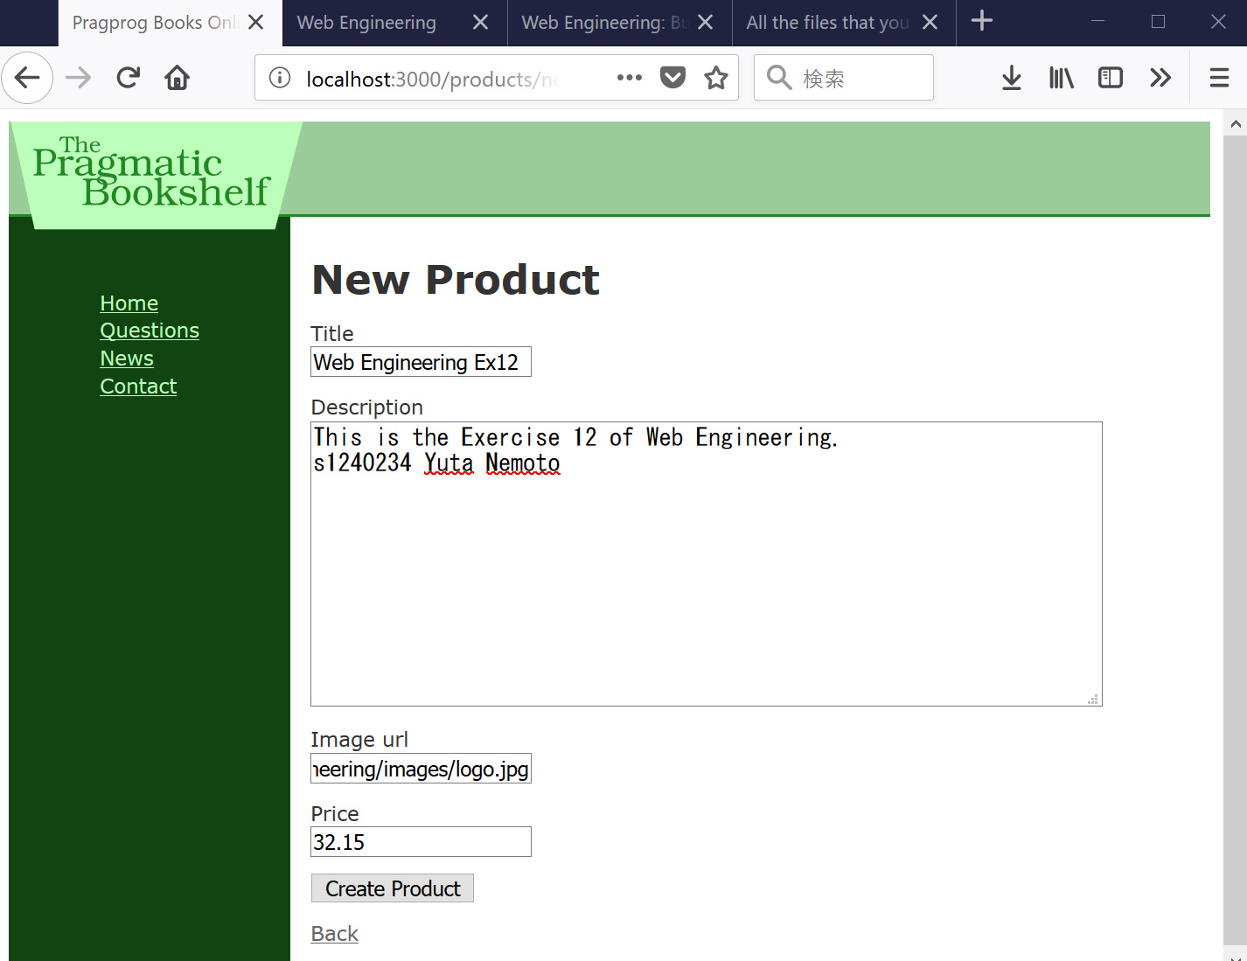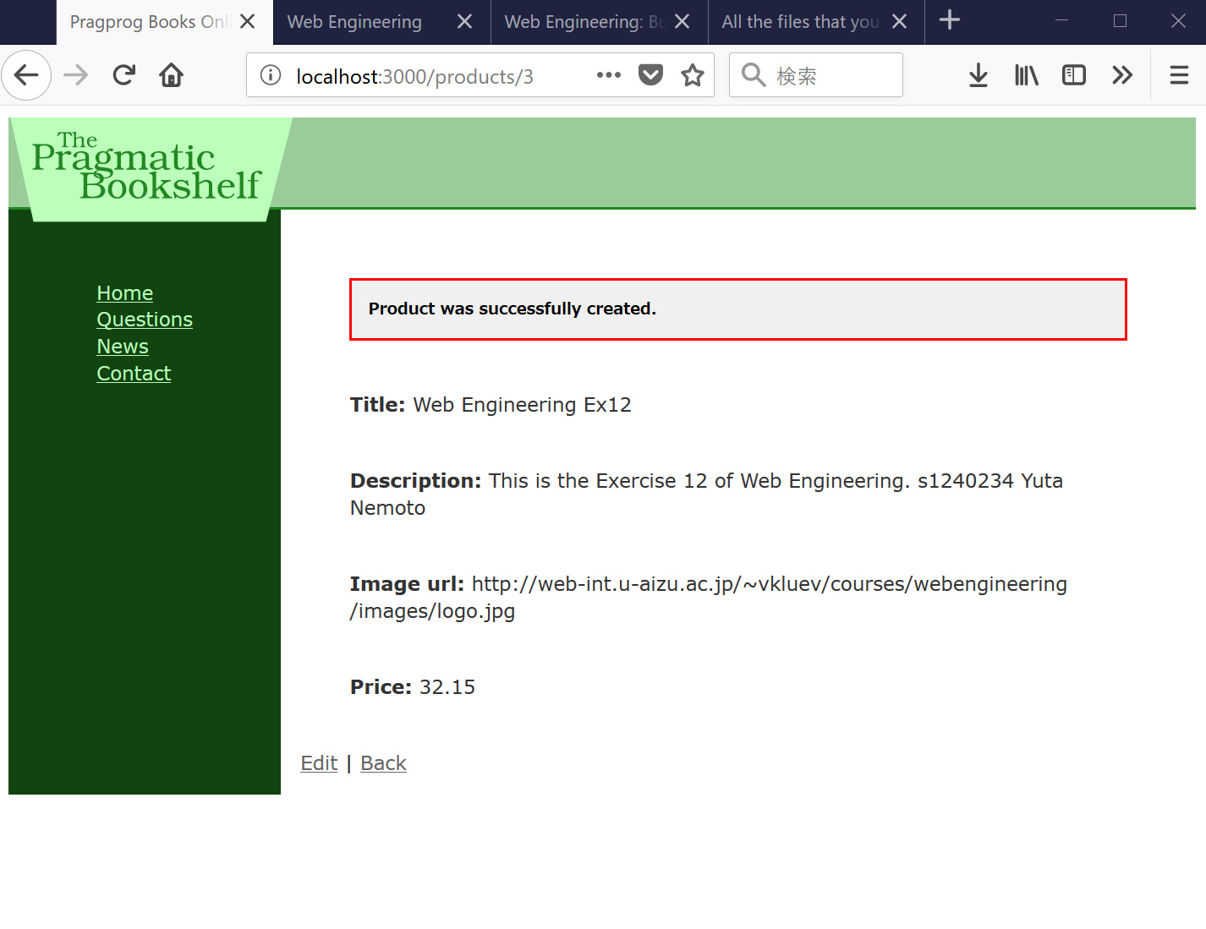

Screenshot: List of Products

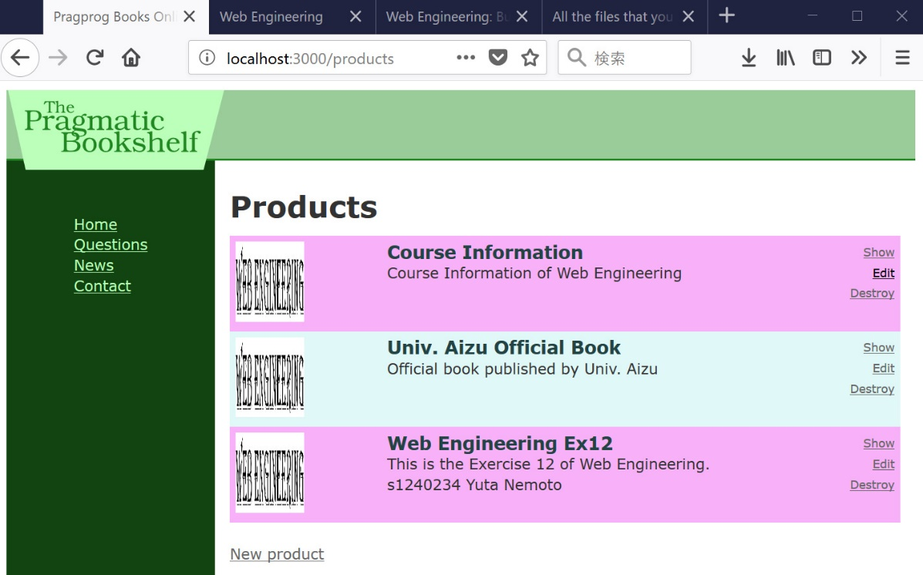

Screenshot: Catalog page – “Add to Cart” button is exactly approved.

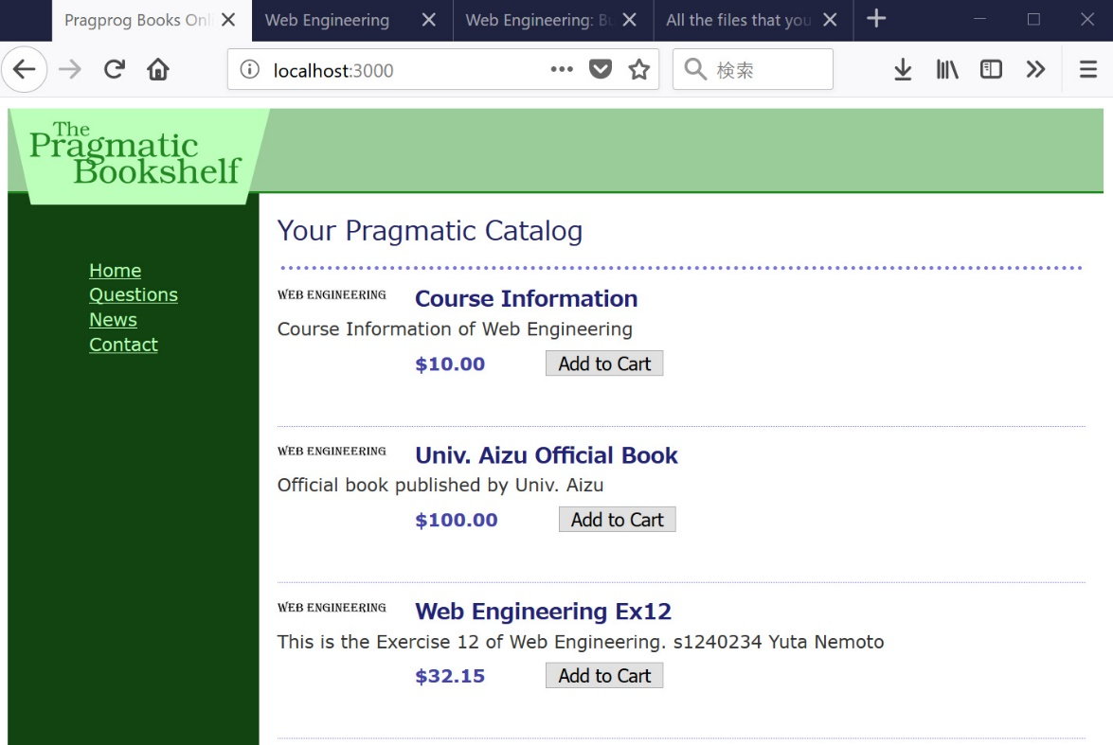

I clicked on the “Add to Cart” button of the book “Course Information”, so the particular book is added to the cart.

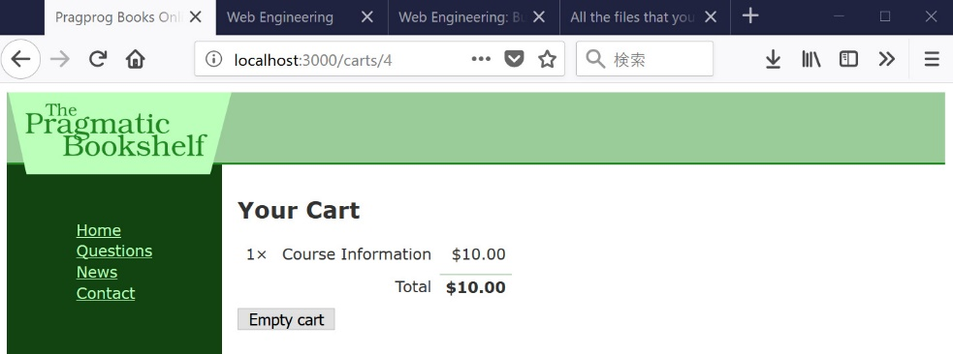

Go back the page and I clicked three times the button of the book “Web Engineering Ex12”, and clicked the button of “Univ. Aizu Official Book”, so multiple books are added to the cart.

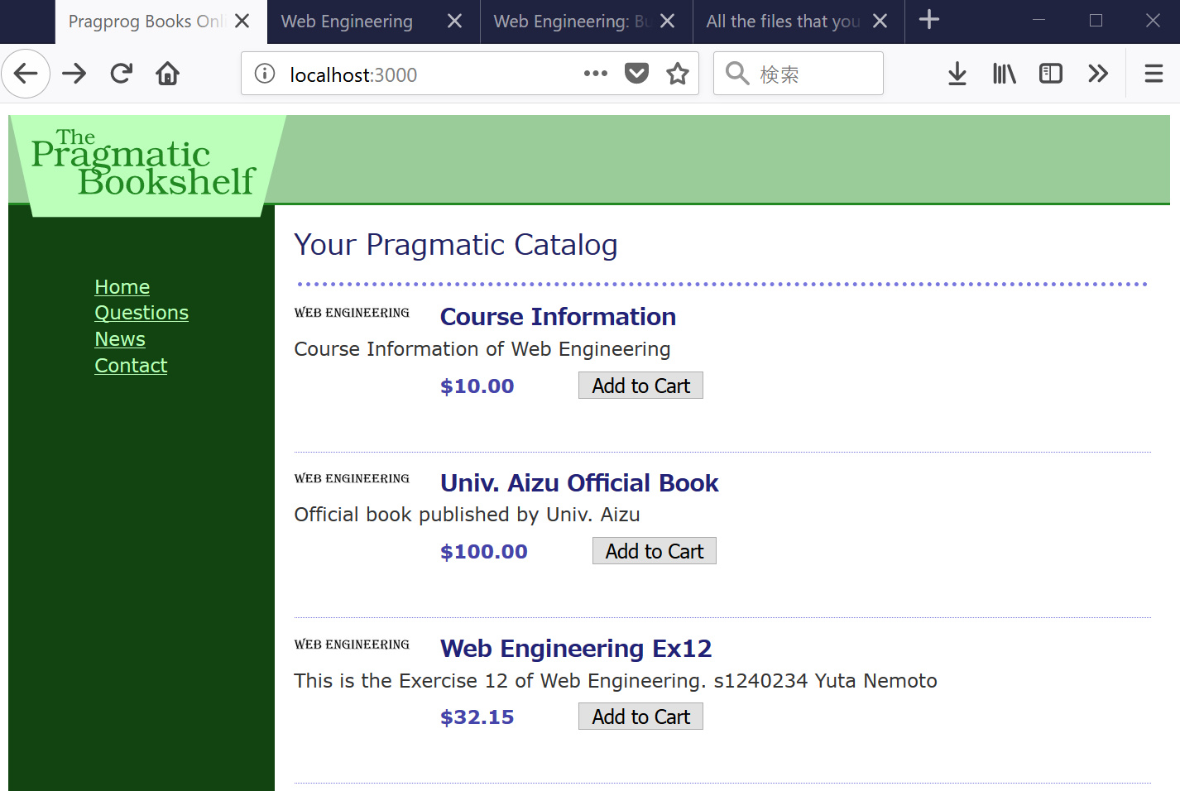

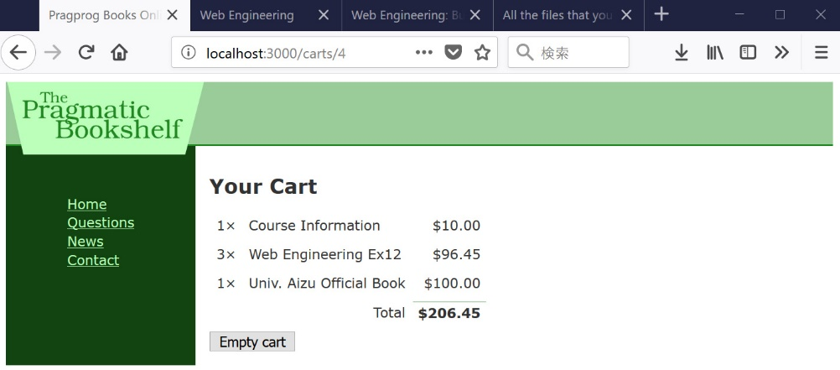

If I click the button “Empty cart”, it shows confirmation dialogue and empty the cart.

